
Department of Computer Science
Subject:
OPERATING SYSTEM

Submitted by:
ABDUL REHMAN SUDAIS

Reg number:
23-NTU-CS-1123

Lab :
6

Semester:
5TH

- TASK 1:
- #include <stdio.h>
- #include <pthread.h>

- #define NUM_THREADS 4
- int varg=0;

- void *thread_function(void *arg) {
- int thread_id = *(int *)arg;

- int varl=0;
- varg++;
- varl++;
- printf("Thread %d is executing the global value is %d: local vale is %d: process id %d: \n", thread_id,varg,varl,getpid());
- return NULL;
- }

- int main() {
- pthread_t threads[NUM_THREADS];
- int thread_args[NUM_THREADS];

- for (int i = 0; i < NUM_THREADS; ++i) {
- thread_args[i] = i;
- pthread_create(&threads[i], NULL, thread_function, &thread_args[i]);
- }

- for (int i = 0; i < NUM_THREADS; ++i) {
- pthread_join(threads[i], NULL);
- }
- printf("Main is executing the global value is %d:: Process ID %d: \n",varg,getpid());

- return 0;
- }
- OUTPUT:
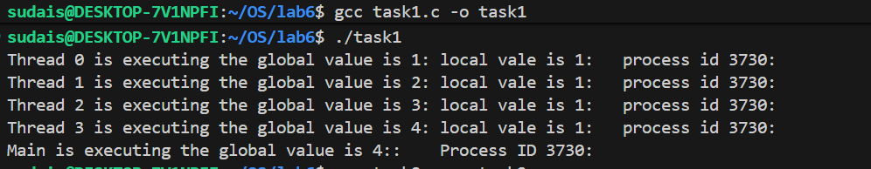
- TASK 2:
- #include <stdio.h>
- #include <pthread.h>
- #include <unistd.h>
- #define NUM_ITERATIONS 1000000

- int count=10;

- // Critical section function
- void critical_section(int process) {
- //printf("Process %d is in the critical section\n", process);
- //sleep(1); // Simulate some work in the critical section
- if(process==0){

- for (int i = 0; i < NUM_ITERATIONS; i++)
- count--;
- }
- else
- {
- for (int i = 0; i < NUM_ITERATIONS; i++)
- count++;
- }

- }

- void *process0(void *arg) {

- // Critical section
- critical_section(0);
- // Exit section

- return NULL;
- }

- void *process1(void *arg) {

- // Critical section
- critical_section(1);
- // Exit section

- return NULL;
- }

- int main() {
- pthread_t thread0, thread1, thread2, thread3;

- // Create threads
- pthread_create(&thread0, NULL, process0, NULL);
- pthread_create(&thread1, NULL, process1, NULL);
- pthread_create(&thread2, NULL, process0, NULL);
- pthread_create(&thread3, NULL, process1, NULL);

- // Wait for threads to finish
- pthread_join(thread0, NULL);
- pthread_join(thread1, NULL);
- pthread_join(thread2, NULL);
- pthread_join(thread3, NULL);

- printf("Final count: %d\n", count);

- return 0;
- }

- OUTPUT:
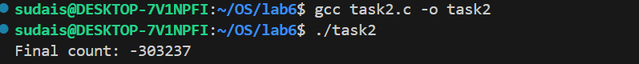

- TASK 3:
- #include <stdio.h>
- #include <pthread.h>
- #include <unistd.h>
- #define NUM_ITERATIONS 100000
- // Shared variables
- int turn;
- int flag[2];
- int count=0;

- // Critical section function
- void critical_section(int process) {
- //printf("Process %d is in the critical section\n", process);
- //sleep(1); // Simulate some work in the critical section
- if(process==0){

- for (int i = 0; i < NUM_ITERATIONS; i++)
- count--;
- }
- else
- {
- for (int i = 0; i < NUM_ITERATIONS; i++)
- count++;

- }
- // printf("Process %d has updated count to %d\n", process, count);
- //printf("Process %d is leaving the critical section\n", process);
- }

- // Peterson's Algorithm function for process 0
- void *process0(void *arg) {

- flag[0] = 1;
- turn = 1;
- while (flag[1]==1 && turn == 1) {
- // Busy wait
- }
- // Critical section
- critical_section(0);
- // Exit section
- flag[0] = 0;
- //sleep(1);

- pthread_exit(NULL);

- }

- // Peterson's Algorithm function for process 1
- void *process1(void *arg) {

- flag[1] = 1;
- turn = 0;
- while (flag[0] ==1 && turn == 0) {
- // Busy wait
- }
- // Critical section
- critical_section(1);
- // Exit section
- flag[1] = 0;
- //sleep(1);

- pthread_exit(NULL);
- }

- int main() {
- pthread_t thread0, thread1;

- // Initialize shared variables
- flag[0] = 0;
- flag[1] = 0;
- turn = 0;

- // Create threads
- pthread_create(&thread0, NULL, process0, NULL);
- pthread_create(&thread1, NULL, process1, NULL);

- // Wait for threads to finish
- pthread_join(thread0, NULL);
- pthread_join(thread1, NULL);

- printf("Final count: %d\n", count);

- return 0;
- }

- OUTPUT:
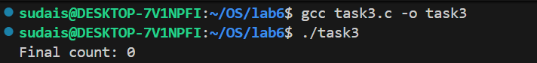

- TASK4:
- #include <stdio.h>
- #include <pthread.h>
- #include <unistd.h>
- #define NUM_ITERATIONS 1000000

- int count=10;

- pthread_mutex_t mutex; // mutex object

- // Critical section function
- void critical_section(int process) {
- //printf("Process %d is in the critical section\n", process);
- //sleep(1); // Simulate some work in the critical section
- if(process==0){

- for (int i = 0; i < NUM_ITERATIONS; i++)
- count--;
- }
- else if (process==1)
- {
- for (int i = 0; i < NUM_ITERATIONS; i++)
- count++;
- }
- else{
- for (int i = 0; i < NUM_ITERATIONS; i++)
- count--;
- }
- //printf("Process %d has updated count to %d\n", process, count);
- //printf("Process %d is leaving the critical section\n", process);
- }

- // Peterson's Algorithm function for process 0
- void *process0(void *arg) {

- pthread_mutex_lock(&mutex); // lock

- // Critical section
- critical_section(0);
- // Exit section

- pthread_mutex_unlock(&mutex); // unlock

- return NULL;
- }

- // Peterson's Algorithm function for process 1
- void *process1(void *arg) {

- pthread_mutex_lock(&mutex); // lock

- // Critical section
- critical_section(1);
- // Exit section

- pthread_mutex_unlock(&mutex); // unlock

- return NULL;
- }

- void *process2(void *arg) {

- pthread_mutex_lock(&mutex); // lock

- // Critical section
- critical_section(2);
- // Exit section

- pthread_mutex_unlock(&mutex); // unlock

- return NULL;
- }

- int main() {
- pthread_t thread0, thread1, thread2, thread3;

- pthread_mutex_init(&mutex,NULL); // initialize mutex

- // Create threads
- pthread_create(&thread0, NULL, process0, NULL);
- // pthread_create(&thread1, NULL, process1, NULL);
- pthread_create(&thread2, NULL, process2, NULL);
- pthread_create(&thread3, NULL, process1, NULL);

- // Wait for threads to finish
- pthread_join(thread0, NULL);
- // pthread_join(thread1, NULL);
- pthread_join(thread2, NULL);
- pthread_join(thread3, NULL);

- pthread_mutex_destroy(&mutex); // destroy mutex

- printf("Final count: %d\n", count);

- return 0;
- }

- OUTPUT:

- MAIN TASK: DIFFERNCE B/W PETERSONS AND MUTEX:
ANS:
Peterson’s algorithm is a complex software-based solution that relies on multiple conditions and busy waiting, making it less practical for real-world use.
It works only for two processes and is difficult to scale.
In contrast, the mutex method is simpler, efficient, and system-supported, allowing easy synchronization among multiple threads without complex conditions.

